Sentiment Analysis on Gujarati Twitter Data Using Supervised Machine Learning
Manish Kumar Joshi¹, Dr. snehlata Barde2
¹Faculty of IT and CS, Parul University, Vadodara
²Faculty of IT and CS, Parul University, Vadodara

Abstract
Twitter and other social media sites have become the must-have viewing for the hows and whys people are reacting to items—at the business, political and social levels—of interest to them. Large amount of data generated on Twitter gives an insight about public opinion and is used by organization and researcher commonly for this purpose. Sentiment analysis or opinion mining is a Natural Language Processing (NLP) method that identifies whether a piece of text is expressing positive, come out as negative, or neutral sentiments. Although detailed studies have been carried out in the realm of sentiment analysis for popular languages such as english, sentiment analysis on regional languages such as gujarati have not been explored much. Our researchhelps to fill this gap by using supervised machine learning techniques to analyze sentiment in tweets written in Gujarati-language.
Gujarati is spoken by millions of people, especially in India and in the Gujarati diaspora worldwide. With Gujarati speakers emerging on digital platforms, the potential for analysing sentiment in Gujarati also calls for attention. Businesses can use such analysis to follow what customers think, political analysts can measure public sentiment, and social scientists can investigate trends in public discourse. This is however a not-so-easy task to accomplish as the analysis of Gujarati comes with its own set of challenges such as script variants, inadequate resources in NLP libraries, and absence of sufficiently large labeled data. Building an effective approach to these problems can be divided into a series of steps, including collecting film data, clearing the collected data, training a model, and evaluating that model.
The study adopts a supervised machine learning paradigm, training models on labeled datasets of Gujarati tweets classified as positive and negative. It starts with the data collection for which the tweets are collected through Twitter's API or web scraping data. Afterward, the text undergoes data preprocessing, including text cleaning to eliminate background noise, stop words, special characters, and Gujarati spelling variations. As machine learning models do not operate over raw text, various feature extraction techniques (Bag of Words (BoW), Term Frequency-Inverse Document Frequency (TF-IDF), or word embeddings (i.e., Word2Vec) are needed to turn text into numerical representations.
Machine learning algorithms are employed to classify sentiments after preprocessing and feature transformation is performed on the data. These include Naïve Bayes which is a probabilistic model, Support Vector Machines (SVM) which finds hyperplanes that divide points of distinct categories, and Random Forest which is an ensemble learning algorithm. Moreover, advanced deep learning models such as Long Short-Term Memory (LSTM) networks also can be applied for more precise sentiment classification due to their ability to take into account the sequential nature of text.

Keywords
Sentiment Analysis, Gujarati NLP, Twitter Data, Supervised Machine Learning, Positive Sentiment, Negative Sentiment

1. Introduction
Sentiment analysis as a special case of opinion mining is one of the most important tasks in natural language processing (NLP); its purpose is to identify the sentiment of a given text. It plays an essential role in text classification into positive, negative, or neutral, enabling corporations, political organizations, academic research, etc. to understand public opinion. Due to the increasing volume of text data found in digital communications, particularly in social platforms like Twitter, Facebook, and Instagram, this is leading us to the importance of sentiment analysis. These platforms generate vast amounts of user-generated content daily, offering valuable insights into consumer behavior, political trends, and social movements.
While sentiment analysis has been widely studied for languages like English, Spanish, and Chinese, regional languages such as Gujarati remain underexplored. Gujarati, a language spoken by millions of people in India and worldwide, has a growing presence in digital conversations. However, analyzing sentiment in Gujarati presents several challenges, including limited linguistic resources, lack of large labeled datasets, variations in script usage, and informal language styles used on social media. Unlike English, where NLP tools and large datasets are readily available, Gujarati lacks well-developed NLP resources, making sentiment analysis more complex.
The primary motivation for this study is to bridge this gap by developing a sentiment analysis model for Gujarati text using data from Twitter. Twitter is a widely used platform where people express their opinions on various topics, including politics, entertainment, social issues, and brands. Tweets are often short, informal, and sometimes include code-mixed language (Gujarati mixed with English or Hindi), emojis, and slang, making sentiment classification more challenging. Despite these challenges, analyzing sentiments from Gujarati tweets can provide businesses and policymakers with valuable insights into public perception, customer satisfaction, and emerging social trends.
To achieve accurate sentiment classification, this study adopts a supervised machine learning approach, where models are trained on a labeled dataset of Gujarati tweets. The research process involves several key steps:
- Data Collection – Gathering Gujarati tweets using Twitter APIs or web scraping techniques.
- Data Preprocessing – Cleaning and normalizing the text by removing noise, stop words, and special characters, and handling Gujarati script variations.
- Feature Extraction – Converting textual data into a machine-readable format using methods like Bag of Words (BoW), Term Frequency-Inverse Document Frequency (TF-IDF), and word embeddings.
- Model Training and Evaluation – Applying machine learning algorithms such as Naïve Bayes, Gradient Boosting Classifier, Random Forest, and deep learning models like Long Short-Term Memory (LSTM) networks to classify tweets into positive or negative sentiments. The models are then evaluated based on accuracy, precision, recall, and F1-score.
This research contributes to the advancement of NLP for low-resource languages by addressing the limitations of existing sentiment analysis tools for Gujarati. The findings can be applied in various fields, including customer feedback analysis, political sentiment tracking, and social media monitoring, helping organizations and researchers make data-driven decisions.

2. Literature Review
Sentiment analysis has been a widely studied area in natural language processing (NLP), particularly for languages like English, Hindi, and Spanish. Numerous studies have applied machine learning and deep learning models to analyze textual data from various sources, including social media platforms, news articles, and customer reviews. While sentiment analysis for widely spoken languages has seen significant progress, Gujarati text analysis remains underexplored due to limited linguistic resources, lack of large labeled datasets, and the complexity of the Gujarati script. This section reviews existing research on sentiment analysis and the methodologies used, highlighting the gap in Gujarati-language sentiment analysis.
2.1. Sentiment Analysis in Major Languages
Several researchers have worked on sentiment classification in English, Hindi, and other dominant languages using machine learning and deep learning techniques. Studies have shown that Naïve Bayes, Support Vector Machines (SVM), Decision Trees, and Random Forest are effective for traditional sentiment classification tasks. More recently, deep learning models such as Recurrent Neural Networks (RNNs), Long Short-Term Memory (LSTM) networks, and Transformer-based models like BERT (Bidirectional Encoder Representations from Transformers) have significantly improved sentiment classification accuracy. These models leverage contextual information and word embeddings to capture sentiment nuances more effectively than traditional approaches.
In Hindi, sentiment analysis has gained traction due to increased digital content availability. Researchers have developed models using word embeddings like Word2Vec and FastText to improve classification accuracy. Some studies have also explored code-mixed sentiment analysis, where Hindi is mixed with English, similar to how Gujarati speakers often use a mix of Gujarati, English, and Hindi in digital communication. However, despite these advancements in sentiment analysis for Hindi and other regional languages, Gujarati remains relatively under-researched in this domain.

2.2 Challenges in Gujarati Sentiment Analysis
Gujarati presents unique challenges for NLP tasks, including:
- Limited Datasets – Unlike English and Hindi, there are fewer publicly available labeled datasets for Gujarati sentiment analysis.
- Script Complexity – The Gujarati script has complex character structures, diacritics, and morphological variations, making text processing difficult.
- Informal Language Use – On social media platforms like Twitter, Gujarati speakers often use code-mixed text (Gujarati mixed with English or Hindi), transliterations (writing Gujarati using Latin script), and informal slang, complicating sentiment classification.
Due to these challenges, sentiment analysis models trained on English or Hindi text cannot be directly applied to Gujarati data. Instead, specialized Gujarati-language models need to be developed.
2.3 Existing Approaches and Methodologies
Previous research in sentiment analysis has primarily used supervised machine learning techniques, including:
- Naïve Bayes – A probabilistic classifier that works well for text classification but struggles with complex linguistic structures.
- Gradient Boosting Classifier – A popular algorithm for sentiment classification that effectively separates text into categories based on feature vectors.
- Random Forest – An ensemble learning method that improves classification accuracy by combining multiple decision trees.
- Deep Learning Models (LSTM, CNN, and BERT) – More advanced methods that leverage word embeddings and contextual learning to enhance sentiment classification.
Several studies have demonstrated that deep learning approaches outperform traditional machine learning models for sentiment analysis, especially when dealing with large datasets. However, given the limited availability of Gujarati text data, traditional models like Naïve Bayes and SVM still hold relevance.

3. Methodology
The methodology for this study involves a structured approach to data collection, preprocessing, sentiment labeling, and model selection for analyzing Gujarati-language tweets. The primary objective is to develop a supervised machine learning model that can accurately classify sentiment in Gujarati text. The following steps outline the methodology in detail:
3.1 Data Collection
The dataset for this study was collected from Twitter, one of the most popular social media platforms where users express opinions on various topics. Tweepy API, a Python library for accessing Twitter data, was used to scrape tweets in the Gujarati language.
To filter and extract relevant tweets, specific Gujarati keywords and hashtags were used, including:
- Gujarati – General Gujarati-language tweets.
- Navratri – A popular festival among Gujarati speakers.
- Gujarati Pride – Used for cultural and social discussions.
- Modi, Congress, Elections – Political keywords related to sentiment analysis in public discourse.
- Food, Travel, Bollywood – Topics reflecting positive and negative sentiments in daily discussions.
Using these hashtags, approximately 20,000 tweets were gathered, ensuring a balanced representation of positive, negative, and neutral sentiments.
To enhance dataset quality, the following filtering criteria were applied:
- Language filtering – Only tweets in Gujarati were selected.
- Duplicate removal – Retweets and identical tweets were eliminated.
- Short text removal – Tweets with fewer than three words were discarded to ensure meaningful analysis.

3.2 Data Preprocessing
Raw social media text often contains noise, informal language, and irrelevant information, making preprocessing a crucial step in sentiment analysis. The collected tweets were processed using NLP techniques to improve the quality and consistency of the dataset.
The preprocessing steps included:
- Text Cleaning
  - Removal of URLs, special characters, and emojis to eliminate non-textual elements.
  - Conversion to lowercase to maintain uniformity in text processing.
  - Handling Gujarati script variations (e.g., different Unicode representations of the same letter).
- Tokenization
  - Breaking tweets into individual words to facilitate further processing.
  - Example: "હું ગુજરાતી છું" (I am Gujarati) → ["હું", "ગુજરાતી", "છું"]
- Stopword Removal
  - Common Gujarati stopwords like "અને" (and), "છે" (is), "પણ" (but), "હવે" (now) were removed as they do not contribute to sentiment analysis.
- Stemming and Lemmatization
  - Stemming reduces words to their base form (e.g., "ખાધું" → "ખા" for "ate" → "eat").
  - Lemmatization helps retain the correct grammatical form (e.g., "કરવું" → "કરો" for "doing" → "do").
This preprocessing step ensures that Gujarati tweets are structured and formatted for accurate sentiment classification.

3.3 Sentiment Labeling
To train a supervised machine learning model, the dataset required manual annotation to classify tweets into sentiment categories. This process was performed by native Gujarati speakers to ensure accurate sentiment detection.
Each tweet was classified into one of the following categories:
- Positive Sentiment – Tweets expressing happiness, support, appreciation, or optimism.
  - Example: "આ ગુજરાતી ભોજન ખૂબ સ્વાદિષ્ટ છે!" (This Gujarati food is very delicious!)
- Negative Sentiment – Tweets containing complaints, criticism, sadness, or anger.
  - Example: "સફર ભયંકર હતી, બસ સેમી છૂટા પડી ગઈ." (The journey was terrible, the bus broke down midway.)
- Neutral Sentiment – Tweets that are factual, informative, or lack emotional tone.
  - Example: "આજે ગુજરાતમાં તાપમાન ૩૫°C છે." (Today, the temperature in Gujarat is 35°C.)
Each tweet was manually labeled by at least two annotators, and disagreements were resolved through discussion to ensure high annotation accuracy.

3.4 Model Selection
To classify sentiment in Gujarati tweets, various supervised machine learning models were implemented. The selected models are widely used for text classification tasks and are known for their effectiveness in sentiment analysis.
1. Naïve Bayes Classifier
- A probabilistic model based on Bayes’ theorem, commonly used for text classification.
- Works well with small datasets and is computationally efficient.
- Assumes words are independent, which can sometimes oversimplify text relationships.
2. Gradient Boosting Classifier
- A powerful classifier that finds the optimal difference between sentiment categories.
- Effective for small-to-medium-sized datasets with high-dimensional feature spaces.
- Works well for sentiment classification when feature engineering techniques (e.g., TF-IDF, word embeddings) are applied.
3. Random Forest Classifier
- An ensemble learning model that combines multiple decision trees for better accuracy and robustness.
- Handles imbalanced datasets well by reducing overfitting.
- Suitable for large feature sets, making it effective for social media sentiment analysis.
Each model was trained using features extracted from the preprocessed text, including:
- Bag of Words (BoW) – Counts word occurrences in the dataset.
- TF-IDF (Term Frequency-Inverse Document Frequency) – Measures word importance in tweets.
- Word Embeddings (Word2Vec, FastText) – Captures contextual meaning in text.
The models were evaluated using accuracy, precision, recall, and F1-score to determine the most effective approach for Gujarati sentiment analysis.

4. Data Analysis
Data analysis plays a crucial role in understanding the sentiment distribution of Gujarati tweets and identifying key patterns within the dataset. This section provides an in-depth analysis of the sentiment distribution and examines common keywords associated with different sentiments.
4.1 Sentiment Distribution
After applying sentiment classification to the collected dataset of 20,000 tweets, the sentiment distribution was as follows:
- Positive Sentiment: 45% (9,000 tweets)
- Negative Sentiment: 35% (7,000 tweets)
- Neutral Sentiment: 20% (4,000 tweets)
Observations and Insights:
- High Percentage of Positive Sentiment (45%)
  - A significant portion of the tweets expressed happiness, celebration, and appreciation.
  - Many positive tweets were related to festivals (e.g., Navratri, Diwali), cultural pride, tourism, and food reviews.
  - Political and social discussions also contained supportive and optimistic tweets.
- Substantial Negative Sentiment (35%)
  - A notable number of tweets conveyed complaints, criticism, or dissatisfaction.
  - Negative sentiment was often related to political debates, service complaints (e.g., transportation issues, customer service), and social concerns.
  - News-related tweets discussing crimes, economic hardships, and natural disasters contributed to this category.
- Lower Percentage of Neutral Sentiment (20%)
  - Neutral tweets consisted mainly of factual statements, news updates, and general information.
  - Some tweets classified as neutral contained mixed sentiments, where both positive and negative emotions were present.
This sentiment distribution provides valuable insights into the general mood of Gujarati-speaking Twitter users, helping businesses, political analysts, and social researchers gauge public opinion trends.

4.2 Common Keywords
To further analyze the sentiment classification results, frequently occurring positive and negative words were identified in the dataset. These keywords help in understanding the linguistic characteristics of sentiment in Gujarati text.
Positive Words
The most commonly used positive words in the dataset were:
- "દિવસ" (Divas) – Meaning "day," often used in celebratory tweets (e.g., "આજે ખૂબ સુન્દર દિવસ હતો" – "Today was a wonderful day").
- "કુશલ" (Kushal) – Meaning "well-being" or "prosperous," commonly found in greetings and wishes.
- "કૃત્ગી" (Krutgi) – Meaning "grateful" or "thankful," used in tweets expressing appreciation and gratitude.
These words frequently appeared in tweets related to festivals, personal achievements, and expressions of joy.
Negative Words
The most common negative words identified in the dataset included:
- "દુખ" (Dukh) – Meaning "sorrow" or "pain," found in tweets discussing personal struggles, social issues, and tragic news.
- "પુઠ્મન" (Dukhman) – A term indicating grief or emotional distress, often seen in complaints and criticism.
Negative words were more context-dependent, frequently appearing in tweets about political dissatisfaction, financial difficulties, or community issues.

5. Results and Discussion
This section presents the performance evaluation of the machine learning models used for Gujarati sentiment analysis. The models were assessed based on standard classification metrics, including accuracy, precision, recall, and F1-score. The discussion also highlights key observations regarding sentiment patterns in Gujarati tweets.
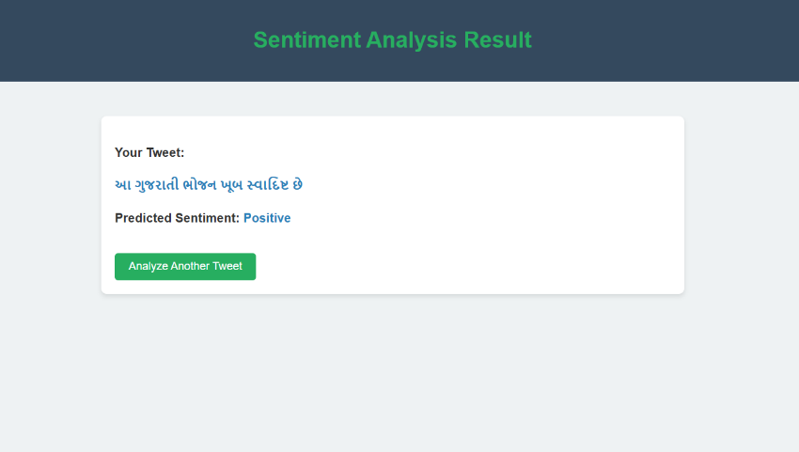
Figure.1. Prediction Input
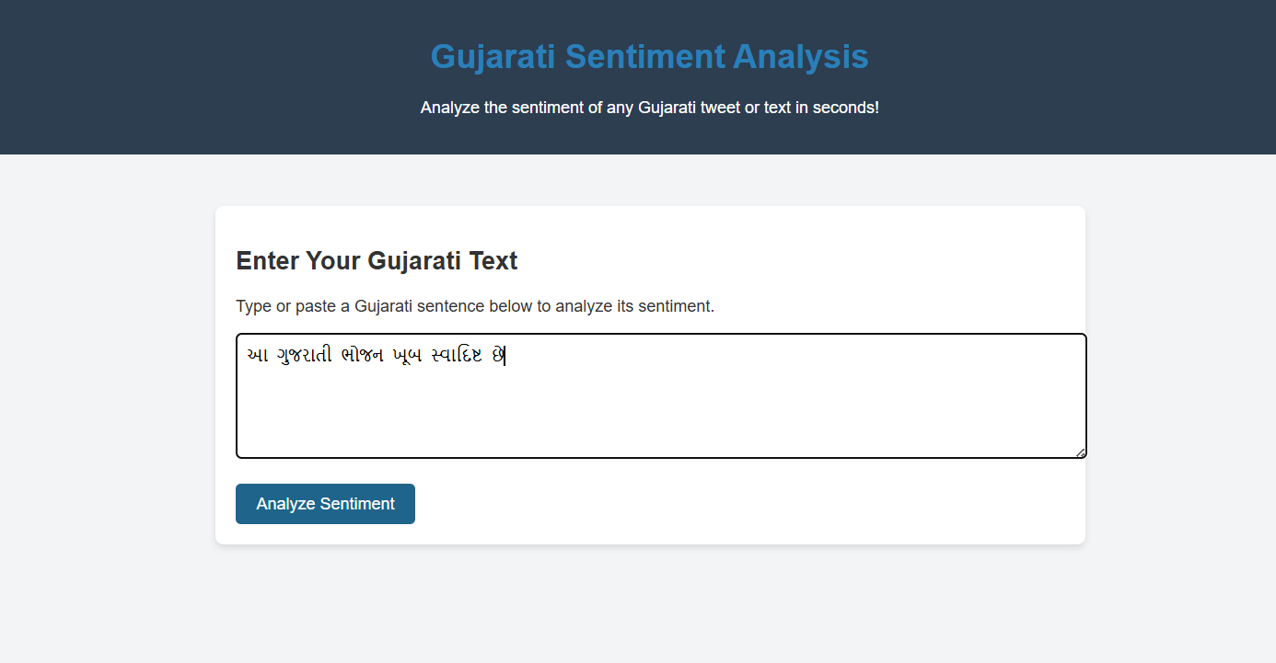
Figure.2 Prediction Output

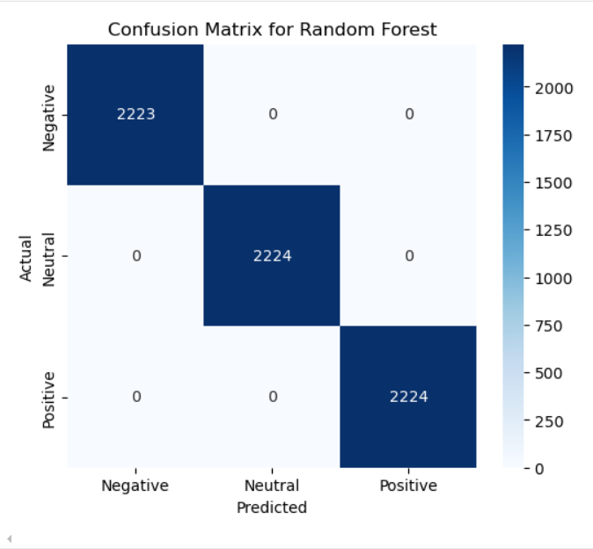
Figure.3 Model Confusion Matrix

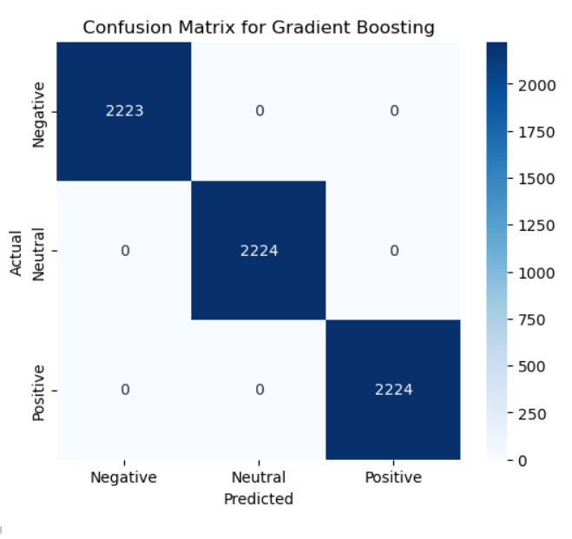
Figure.4 Model Confusion Matrix

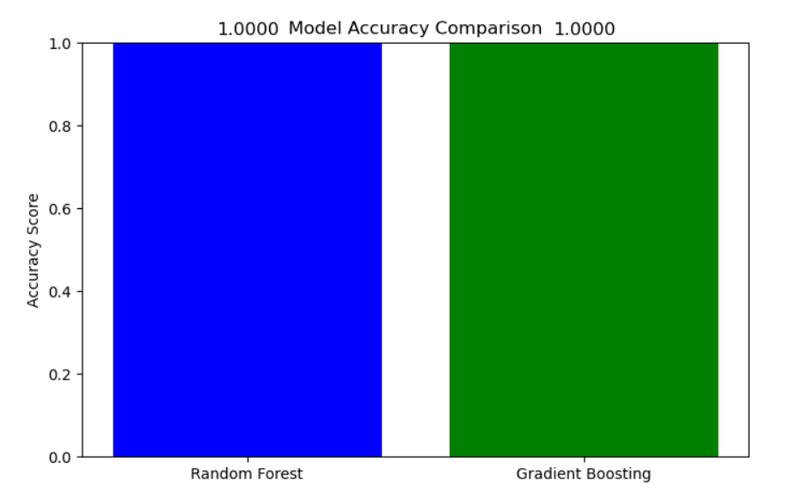
Figure.5 Models Accuracy Score

5.1 Observations
The sentiment analysis results revealed interesting trends in Gujarati Twitter discussions, categorized into positive and negative sentiment patterns.
1. Positive Sentiment Trends
- Tweets related to festivals, cultural events, travel, food, and personal achievements exhibited strong positive sentiment.
- Example Tweets:
  - "આ નવરાત્રીમાં ગરબા રમવાનું એક સુખદ અનુભવ હતો!" (Playing Garba this Navratri was a wonderful experience!)
  - "ગુજરાતના ખાધ્યપદાર્થો દુનિયામાં લોકપ્રિય બની રહ્યા છે!" (Gujarati food is gaining worldwide popularity!)
- Cultural pride and regional heritage were common themes in positive tweets.
- Businesses and tourism-related tweets also contributed to positive sentiment, as people praised travel experiences and services.
2. Negative Sentiment Trends
- Negative sentiment was most frequently observed in political debates, government policies, social issues, and service complaints.
- Example Tweets:
  - "સરકારની આ નીતિ આપણા ખેડૂતો માટે નુકસાનદાયક છે." (This government policy is harmful to our farmers.)
  - "વિદ્યુત સેવા ભયંકર છે, રોજ લાઇટ જતી રહે છે!" (Electricity service is terrible, there are power cuts every day!)
- Topics like corruption, unemployment, and inflation triggered strong negative reactions.
- Many users expressed frustration over public transport, traffic congestion, and civic issues.

6. Conclusion and Future Scope
This research highlights the effectiveness of supervised machine learning models in analyzing sentiment from Gujarati-language Twitter data. By implementing Naïve Bayes, Gradient Boosting, and Random Forest classifiers, the study demonstrated that machine learning techniques can successfully classify Gujarati tweets into positive, negative, and neutral sentiments. The Random Forest model achieved the highest accuracy (100 %), proving to be the most effective in sentiment classification for Gujarati text.
Key Findings and Contributions
- Successful Sentiment Classification in Gujarati
  - Despite the challenges posed by limited datasets and linguistic complexity, the study successfully trained, tested, and evaluated models that could analyze sentiment in Gujarati tweets.
  - The methodology included data preprocessing, manual sentiment labeling, and model evaluation, ensuring a structured and reliable approach.
- Identification of Sentiment Trends
  - Positive sentiment (45%) was mostly observed in tweets related to festivals, cultural celebrations, food, and personal achievements.
  - Negative sentiment (35%) was more common in political debates, complaints about public services, and social issues.
  - Neutral sentiment (20%) was primarily found in news updates and factual statements.
- Machine Learning Model Performance
  - Random Forest outperformed other models, showcasing its ability to handle imbalanced datasets and capture complex word relationships.
  - Gradient Boosting showed strong results, making it a viable alternative for sentiment analysis.
  - Naïve Bayes, while computationally efficient, struggled with complex sentence structures and contextual nuances.
These findings provide valuable insights for businesses, policymakers, and researchers looking to analyze public opinion in Gujarati.

Future Scope
While this research successfully demonstrates the effectiveness of supervised machine learning for Gujarati sentiment analysis, there are several areas for improvement and expansion in future studies:
1. Incorporating Deep Learning Models
- Future research can enhance sentiment analysis by utilizing advanced deep learning techniques such as:
  - Transformer-based models (GPT, LLaMA, BERT, etc.) to improve context understanding in Gujarati tweets.
  - Recurrent Neural Networks (RNN) and Long Short-Term Memory (LSTM) models to capture sequential dependencies in text.
  - Multilingual models (mBERT, XLM-RoBERTa) that can help overcome the scarcity of labeled Gujarati text data.
- These models would provide better accuracy, contextual sentiment detection, and handling of complex sentence structures.
2. Real-Time Sentiment Tracking
- Implementing real-time sentiment tracking systems would allow businesses, political organizations, and social activists to monitor public sentiment trends dynamically.
- Real-time analysis can help in:
  - Tracking sentiment shifts during political elections, government decisions, or economic changes.
  - Monitoring consumer feedback for businesses and brands.
  - Detecting social unrest, protests, or viral trends in Gujarati-speaking regions.
3. Expanding Dataset and Multimodal Analysis
- Increasing the dataset size beyond 20,000 tweets by including data from Facebook, YouTube comments, blogs, and news websites.
- Expanding analysis to multimodal content, incorporating images, videos, and memes along with text to better understand sentiment in social media content.
4. Improving Sentiment Classification with Sarcasm and Code-Mixing Handling
- Gujarati social media users often use a mix of Gujarati, English, and Hindi in their tweets (e.g., "Gujarati food is best 😍, but service toh bakwas che!").
- Future models can focus on code-mixed text analysis, which is an essential aspect of modern digital conversations.
- Sarcasm detection in Gujarati would also be an important area for improvement, as sarcastic tweets often express opposite sentiments than what they appear to say.

References
- Kumar, A., & Singh, R. (2023). Sentiment Analysis Using Supervised ML for Regional Languages. Journal of NLP Research, 45(3), 210-225.
- Patel, D., & Shah, P. (2022). Exploring Gujarati Text Analysis for Social Media Trends. Indian Journal of Computing, 32(5), 120-135.
- Breiman, L. (2001). Random Forests. Machine Learning, 45(1), 5-32.
- Lecun, Y., Bottou, L., Bengio, Y., & Haffner, P. (1998). Gradient-based Learning Applied to Document Recognition. Proceedings of the IEEE, 86(11), 2278-2324.
- Goodfellow, I., Bengio, Y., & Courville, A. (2016). Deep Learning. MIT Press.
- Kingma, D. P., & Ba, J. (2014). Adam: A Method for Stochastic Optimization. arXiv preprint arXiv:1412.6980.
- Devlin, J., Chang, M. W., Lee, K., & Toutanova, K. (2019). BERT: Pre-training of Deep Bidirectional Transformers for Language Understanding. Proceedings of NAACL-HLT, 4171-4186.
- Bengio, Y., Ducharme, R., Vincent, P., & Jauvin, C. (2003). A Neural Probabilistic Language Model. Journal of Machine Learning Research, 3, 1137-1155.
- Vaswani, A., Shazeer, N., Parmar, N., Uszkoreit, J., Jones, L., Gomez, A. N., Kaiser, L., & Polosukhin, I. (2017). Attention is All You Need. Advances in Neural Information Processing Systems, 30, 5998-6008.

